|  |  |
| --- | --- |
| *Pacific Gas and Electric Company* | |
| Release 9.8.5 Installation Guide | |
|  |  |
|  |  |
| Project | ED AM/GIS |
|  |  |
| Prepared by | Dale Avery |
| Date | 11/17/2015 |
| Version | 1.0 |
| Version Type | Draft |

|  |  |  |  |
| --- | --- | --- | --- |
| Revision History | | | |
| Document # | Date | Author | Summary of Changes |
| 1.0 | 11/9/2015 | Dale Avery | Initial Document Creation |
|  |  |  |  |
|  |  |  |  |

Contents

1 Introduction 4

1.1 Purpose 4

1.2 Terms Used 4

1.3 External Documents 4

1.4 List of Fixes 5

2 EDGIS 9.8.5 6

2.1 Create CC&B Staging Tables 6

2.2 Create Indexes on Service Point and CWOT tables . 8

2.3 Apply permissions for PGEDATA to access resources used for CCB interface 11

2.4 25339: Modify ROBC Table. 13

2.5 25461: Execute ROBC Changes. 13

3 DM change 9.8.5 A 14

3.1 25671: Assign Prevent Edit for ROBC AU to ROBC table and PartialCurtailPoint Table 14

3.2 25670: Configure GDBM: Add new Action Handlers for Recalculating Established ROBC 16

3.3 25587: ROBC Table Fields "HASESSENTIALIDC" and "LASTCHECKEDDATE" 18

4 DM change 9.8.5 B 19

4.1 25559: DM Change for ECTP SSD Report - Add New Field SSDGUID to Transformer, PrimaryMeter and DCRectifier Features 19

4.2 25686: Modify Device Manufacturer E2 Description to EATON in Device Manufacturer Domain and ED0006 domains.xml 20

4.3 25830: Assign PGE_CGC12 field model name to CGC12 field of ServicePoint table 21

5 Update Data Model Version Table 22

6 Known Issues 23

# Introduction

## Purpose

This document is intended to detail the implementation and configuration steps required to implement Release 9.7.6 Installation Guide. This document describes the various configuration aspects required to complete any manual or automatic patch associated with this release. Each section in this document contains the steps required to patch the system in production.

## Terms Used

|  |  |
| --- | --- |
| OOTB | Out of the box. Unmodified from the commercial version. |
| TFS | Team Foundation Server |

## External Documents

Referenced are any external configuration documents or exports. These are documents that contain more detailed information about configuring a system or documents that can be loaded into an application to perform the configuration detailed in this document.

1. Supporting documentation folder
   1. **TFS documentation location:**

$/EDAMGIS/Source_Development_10_2_1/Documentation/Data Model/Release Documentation/EDER/9.8

<http://edappgistfsprd1:8080/tfs/ElectricDistCollection/EDAMGIS/_versionControl#path=%24%2FEDAMGIS%2FSource_Development_10_2_1%2FDocumentation%2FData+Model%2FRelease+Documentation%2FEDER%2F9.8&_a=contents>

25525

## List of Fixes

Below is the list of change requests detailing all fixes for the data model for this release:

|  |  |
| --- | --- |
| **Item Number** | **Title** |
| [25678](http://edappgistfsprd1:8080/tfs/ElectricDistCollection/EDAMGIS/_workitems/edit/25678) | **Master TFS Data Model 9.8.5** |
| [17290](http://edappgistfsprd1:8080/tfs/ElectricDistCollection/EDAMGIS/_workitems/edit/17290) | Create CC&B Staging Tables |
| [25477](http://edappgistfsprd1:8080/tfs/ElectricDistCollection/EDAMGIS/_workitems/edit/25477) | Create indexes on Service Point and CWOT Tables |
| 25525 | Apply permissions for PGEDATA to access resources used for CCB INTERFACE |
| [25339](http://edappgistfsprd1:8080/tfs/ElectricDistCollection/EDAMGIS/_workitems/edit/25339) | Modify ROBC Table |
| [25461](http://edappgistfsprd1:8080/tfs/ElectricDistCollection/EDAMGIS/_workitems/edit/25461) | Execute ROBC Changes |
| [25587](http://edappgistfsprd1:8080/tfs/ElectricDistCollection/EDAMGIS/_workitems/edit/25587) | ROBC Table Fields "HASESSENTIALIDC" and "LASTCHECKEDDATE" |
| [25671](http://edappgistfsprd1:8080/tfs/ElectricDistCollection/EDAMGIS/_workitems/edit/25671) | Assign Prevent Edit for ROBC AU to ROBC table and PartialCurtailPoint Table |
| [25670](http://edappgistfsprd1:8080/tfs/ElectricDistCollection/EDAMGIS/_workitems/edit/25670) | Configure GDBM: Add new Action Handlers for Recalculating Established ROBC |
| [25559](http://edappgistfsprd1:8080/tfs/ElectricDistCollection/EDAMGIS/_workitems/edit/25559) | DM Change for ECTP SSD Report - Add New Field SSDGUID to Transformer, PrimaryMeter and DCRectifier Features |
| [25686](http://edappgistfsprd1:8080/tfs/ElectricDistCollection/EDAMGIS/_workitems/edit/25686) | Modify Device Manufacturer E2 Description to EATON in Device Manufacturer Domain and ED0006 domains.xml |
| [25830](http://edappgistfsprd1:8080/tfs/ElectricDistCollection/EDAMGIS/_workitems/edit/25830) | Assign PGE_CGC12 field model name to CGC12 field of ServicePoint table |
|  |  |

# EDGIS 9.8.5

## Create CC&B Staging Tables

Execute the following sql to create the following database objects:

* 1. **CC&B in-bound staging table (PGE_CCBTOEDGIS_STG).**

create table PGE_CCBTOEDGIS_STG(  
SERVICEPOINTID nvarchar2 (100),  
CGC12 number (38,8),  
NEWROBC nvarchar2 (3),  
CIRCUITID nvarchar2 (9),  
SOURCESIDEDEVICEID nvarchar2 (20),  
ESSENTIALCUSTOMERIDC nvarchar2 (1),  
UNIQUESPID nvarchar2 (20),  
PREMISEID number (12),  
ACCOUNTNUM nvarchar2 (10),  
SERVICEAGREEMENTID nvarchar2 (10),  
METERNUMBER nvarchar2 (18),  
INSERVICEDATE date,  
NAICS number (38),  
BILLINGCYCLE nvarchar2 (4),  
LOCALOFFICEID nvarchar2 (4),  
METERROUTE nvarchar2 (10),  
REVENUEACCOUNTCODE nvarchar2 (8),  
SENSITIVECUSTOMERIDC nvarchar2 (1),  
LIFESUPPORTIDC nvarchar2 (1),  
RATESCHEDULE nvarchar2 (8),  
MAILNAME1 nvarchar2 (50),  
MAILNAME2 nvarchar2 (50),  
SERVICEADDRESS1 nvarchar2 (255),  
SERVICEADDRESS2 nvarchar2 (255),  
STREETNUMBER nvarchar2 (25),  
STREETNAME1 nvarchar2 (64),  
STREETNAME2 nvarchar2 (64),  
CITY nvarchar2 (40),  
STATE nvarchar2 (2),  
ZIP nvarchar2 (10),  
AREACODE number (3),  
PHONENUM nvarchar2 (13),  
MAILADDR1 nvarchar2 (254),  
MAILADDR2 nvarchar2 (254),  
MAILSTREETNUM nvarchar2 (12),  
MAILSTREETNAME1 nvarchar2 (64),  
MAILSTREETNAME2 nvarchar2 (64),  
MAILCITY nvarchar2 (30),  
MAILSTATE nvarchar2 (2),  
MAILZIPCODE nvarchar2 (10),  
TOWNSHIPTERRITORYCODE nvarchar2 (10),  
PREMISETYPE nvarchar2 (100),  
BATCHDATE date,  
SPPEAKKWHR number (8,1),  
SPPEAKKW number (8),  
SPPFACTOR number (3),  
NETENERGYMETERING nvarchar2 (1),  
SMFLG nvarchar2 (2),  
RADIOMANUFACTURER nvarchar2 (30),  
RADIOSERIALNUM nvarchar2 (25),  
MEDICALBASELINE nvarchar2 (2),  
SCADACOMM nvarchar2 (5),  
ACTION nvarchar2 (1),  
DATECREATED DATE,  
CUSTOMERTYPE nvarchar2(3), OBJECTID number);

* 1. **CC&B out-bound staging table (PGE_EDGISTOCCB_STG).**

CREATE TABLE PGE_EDGISTOCCB_STG(  
UNIQUESPID NVARCHAR2(20),  
SERVICEPOINTID NVARCHAR2(100),  
ROBC NVARCHAR2(3),  
SOURCESIDEDEVICEID NVARCHAR2(20),  
CGC12 NUMBER(12),  
CIRCUITID NVARCHAR2(9),  
UPDATE_DTM DATE,  
UPDATE_USERID NVARCHAR2(15)) ;

* 1. **CC&B processing error table (PGE_CCBTOEDGIS_STG_ERRORS).**

CREATE TABLE PGE_CCBTOEDGIS_STG_ERRORS(  
ERROR_ID timestamp,  
ERROR_DESCRIPTION varchar2(300),  
ERROR_TIMESTAMP timestamp,  
FIELD_IN_ERROR varchar2(50));

* 1. **Create database indexes to improve processing efficiency.**

create index SPID_CCBACTION_IDX on PGEDATA.PGE_CCB_SP_ACTION(SERVICEPOINTID);

create index ACTION_CCBSPACTION_IDX on PGEDATA.PGE_CCB_SP_ACTION(ACTION, SERVICEPOINTID);

create index SPID_USPID_METNUM_DATE_IDX on PGEDATA.PGE_CCBTOEDGIS_STG(UNIQUESPID, SERVICEPOINTID, METERNUMBER, DATECREATED);

create index SPID_SPID_DATE_CR_IDX on PGEDATA.PGE_CCBTOEDGIS_STG(SERVICEPOINTID,DATECREATED);

create index UNIQUESPID_STG_IDX on PGEDATA.PGE_CCBTOEDGIS_STG(UNIQUESPID);

* 1. **Grant database privileges.**

grant all on PGE_EDGISTOCCB_STG to gisinterface;  
grant all on PGE_CCBTOEDGIS_STG to gisinterface;

grant all on PGE_CCBTOEDGIS_STG_ERRORS to gisinterface;

grant select on PGE_EDGISTOCCB_STG to sde_viewer;  
grant select on PGE_CCBTOEDGIS_STG to sde_viewer;

grant all on PGE_CCBTOEDGIS_STG_ERRORS to sde_viewer;

grant all on PGE_EDGISTOCCB_STG to sde_editor;  
grant all on PGE_CCBTOEDGIS_STG to sde_editor;

grant all on PGE_CCBTOEDGIS_STG_ERRORS to sde_editor;

## Create Indexes on Service Point and CWOT tables .

Modify the following database objects using ArcCatalog and sql:

* 1. **Create CWOT indexes**

#1 Open ArcCatalog

#2 Connect as the EDGIS user to the database to change

#3 right click on the CWOT table, right click and choose properties

#4 click the indexes tab

#5 add a new index:

NAME: CWOT_RESOL_IDX

Field: RESOLVED

#6 click ok

#7 add another index on CWOT:

NAME: GDB_957_SERVICEP

Field: SERVICEPOINTGUID

#8 click ok

#9 add another index on CWOT:

NAME: CWOT_SP_IDX

Field: SERVICEPOINT

#10 click ok

* 1. **Create Service Point indexes**

#1 Open ArcCatalog

#2 Connect ad the EDGIS user to the database to be updated

#3 Browse to the table: SERVICEPOINT, right click and choose properties

#4 Select the Indexes tab

#5 Add the following indexes:

NAME: SERVICEPOINT_SCD_IDX FIELDS: SUBTYPECD

NAME: SERVICEPOINT_OPN_IDX FIELDS: SERVICEPOINTID

NAME: SERVICEPOINT_MTN_IDX FIELDS: METERNUMBER

NAME: SERVICEPOINT_STA_IDX FIELDS: STATUS

NAME: SERVICEPOINT_USP_IDX FIELDS: UNIQUESPID

NAME: SERVICEPOINT_GID_IDX FIELDS: GLOBALID

NAME: SERVICEPOINT_OID_IDX FIELDS: GLOBALID,OBJECTID

#7 click ok

* 1. **Modify the Service Point table.**

#1 Open ArcCatalog

#2 Connect as the EDGIS user

#3 select the SERVICEPOINT table, right click and choose properties

#4 select the field tab

#5 Add a temporary field:

NAME: TEMPFIELD

TYPE: TEXT

LENGTH: 25

#6 hit ok

#7 open a Windows command prompt

#8 connect using SQLPLUS as the edgis user

#9 run the following SQL:

update EDGIS.SERVICEPOINT set TEMPFIELD=STREETNUMBER;

update EDGIS.A71 set TEMPFIELD=STREETNUMBER;

commit;

#10 Open ArcCatalog

#11 Connect as the EDGIS user

#12 select the SERVICEPOINT table, right click and choose properties

#13 select the field tab

#14 Delete the field:

NAME: STREETNUMBER

#15 Hit ok and close the dialog

#16 select the SERVICEPOINT table, right click and choose properties

#17 select the field tab

#18 Add the field:

NAME: STREETNUMBER

ALIAS: Street Number

TYPE: TEXT

LENGTH: 25

#19 hit ok

#20 open a Windows command prompt

#21 connect using SQLPLUS as the EDGIS user

#22 run the following SQL:

update EDGIS.SERVICEPOINT set STREETNUMBER=TEMPFIELD;

update EDGIS.A71 set STREETNUMBER=TEMPFIELD;

commit;

#23 Open ArcCatalog

#24 Connect as the EDGIS user

#25 select the SERVICEPOINT table, right click and choose properties

#26 select the field tab

#27 Delete the field:

NAME: TEMPFIELD

#28 Hit ok and close the dialog

## Apply permissions for PGEDATA to access resources used for CCB interface

Create database objects and assign database privleges to the appropriate GIS database objects.

#1 open a Windows command prompt

#2 connect using SQLPLUS as the EDGIS user

#3 run the following SQL:

CREATE OR REPLACE FUNCTION GDB_GUID  
RETURN NCHAR  
IS  
guid NCHAR (38);  
BEGIN  
guid := upper(RAWTOHEX(SYS_GUID()));  
RETURN  
'{'||substr(guid,1,8)||'-'||substr(guid,9,4)||'-'||substr(guid,13,4)||'-'||substr(guid,17,4)||'-'||substr(guid,21,12)||'}';  
END;  
/

grant all on EDGIS.ZZ_MV_SERVICEPOINT to PGEDATA,gis_i,gis_i_write;  
grant all on EDGIS.ZZ_MV_CWOT to PGEDATA,gis_i,gis_i_write;  
grant all on EDGIS.ZZ_MV_PRIMARYMETER to PGEDATA,gis_i,gis_i_write;  
grant all on EDGIS.ZZ_MV_TRANSFORMER to PGEDATA,gis_i,gis_i_write;  
grant all on EDGIS.ZZ_MV_CIRCUITSOURCE to PGEDATA,gis_i,gis_i_write;  
grant all on EDGIS.GDB_GUID to PGEDATA,gis_i,gis_i_write;  
grant all on EDGIS.ZZ_MV_ROBC to PGEDATA,gis_i,gis_i_write;

grant all on EDGIS.ZZ_MV_TRANSFORMERUNIT to PGEDATA,gis_i,gis_i_write;

grant all on EDGIS.SERVICEPOINT to PGEDATA,gis_i,gis_i_write;

grant all on EDGIS.CWOT to PGEDATA,gis_i,gis_i_write;

grant all on EDGIS.PRIMARYMETER to PGEDATA,gis_i,gis_i_write;

grant all on EDGIS.TRANSFORMER to PGEDATA,gis_i,gis_i_write;

grant all on EDGIS.CIRCUITSOURCE to PGEDATA,gis_i,gis_i_write;

grant all on EDGIS.GDB_GUID to PGEDATA,gis_i,gis_i_write;

grant all on EDGIS.ROBC to PGEDATA,gis_i,gis_i_write;

grant all on EDGIS.A71 to PGEDATA,gis_i,gis_i_write;

grant all on EDGIS.A76 to PGEDATA,gis_i,gis_i_write;

grant all on EDGIS.A130 to PGEDATA,gis_i,gis_i_write;

grant all on EDGIS.A117 to PGEDATA,gis_i,gis_i_write;

grant all on EDGIS.A98 to PGEDATA,gis_i,gis_i_write;

grant all on EDGIS.A77 to PGEDATA,gis_i,gis_i_write;

## 25339: Modify ROBC Table.

Modify the table using the Python script.

1. Copy the **ROBC**.**py** file locally from the shared folder from the TFS folder:

<http://edappgistfsprd1:8080/tfs/ElectricDistCollection/EDAMGIS/_versionControl#path=%24%2FEDAMGIS%2FSource_Development_10_2_1%2FDocumentation%2FData+Model%2FRelease+Documentation%2FEDER%2F9.8.5&_a=contents>

1. Right click on the .py file and open it in IDLE editor.
2. **Edit** the “**Data_Connection”** in the file to use the correct SDE file. This SDE file should connect to the database as EDGIS.
3. Release all existing locks in the SDE to ensure exclusive connection.
4. Execute the script.
5. Ensure there is no error occurred.
6. Copy the logs into a text file and attach to the TFS ticket.

## 25461: Execute ROBC Changes.

Modify ROBC using sql:

Download the sql script (ROBC_changes_for_TLM.sql) from TFS ([TFS 25461](http://edappgistfsprd1:8080/tfs/ElectricDistCollection/EDAMGIS/_workitems/edit/25461)).

* + 1. Open a Command prompt and launch sql+.
    2. Execute the sql script.

# DM change 9.8.5 A

This data model change is dependent on the successful installation of new EDER Desktop build.

## 25671: Assign Prevent Edit for ROBC AU to ROBC table and PartialCurtailPoint Table

**Execute this CR after CR# 25339.**

1. Open ArcCatalog and connect to the database with EDGIS user.
2. Navigate to ROBC table. Right click on it. Select ArcFM Properties Manager.
3. Go to Model Names tab. Assign PGE_ROBC model name.
4. Click on Apply.

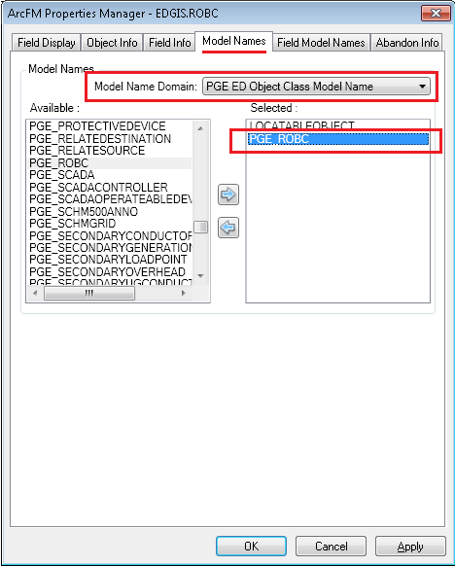

1. Go to Object Info tab.
2. Add PGE Prevent Edit of ROBC in “On Feature Create”, “On Feature Update” and “On FeaTURE Delete”.

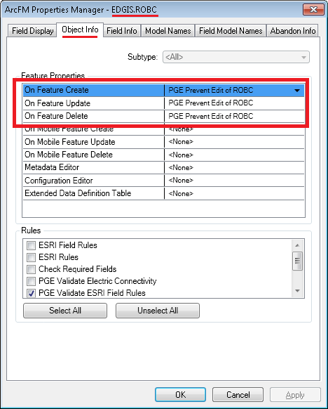

1. Click Apply. Click OK.
2. Navigate to EDGIS.PartialCurtailPoint table. Right click on it. Select ArcFM Properties Manager. Repeat step#3 to step#7.

## 25670: Configure GDBM: Add new Action Handlers for Recalculating Established ROBC

This GDBM configuration needs new EDER Desktop build (build 36 or later) to be installed.

1. Stop GDBM services.
2. In the “Version Processing“ tab of the “Post” service, navigate to “Before Post”.
3. Add a new Action Handler after “Run Feeder Sync” as given below:

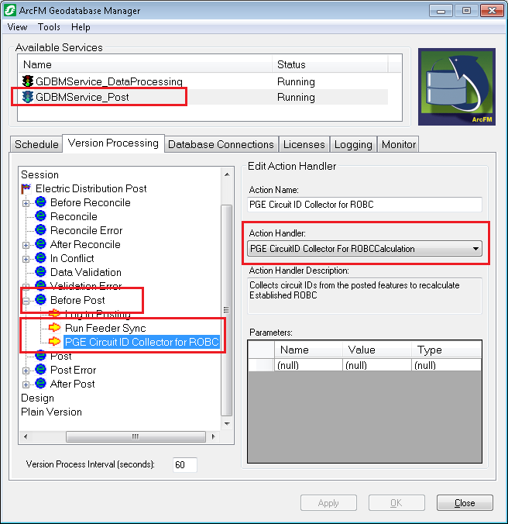

1. Click on “Apply” button.
2. Navigate to “After Post”. Add a new Action Handler at the end as given below:

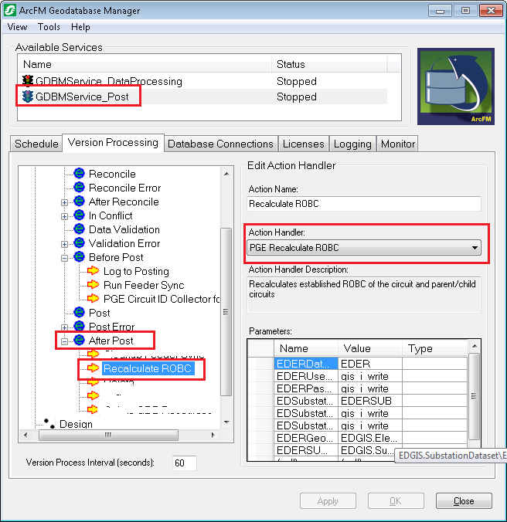

In parameter section add following parameters in the new action handler.

**Name** **Value**

EDERDatabaseTNSName EDER

EDERUserName gis_i_write

EDERPassword gis_i_write

EDSubstationDatabaseTNSName EDERSUB

EDSubstationUserName gis_i_write

EDSubstationPassword gis_i_write

EDERGeometricNetworkName EDGIS.ElectricDataset\EDGIS.ElectricDistNetwork

EDERSUBGeometricNetworkName EDGIS.SubstationDataset\EDGIS.SubGeometricNetwork

## 25587: ROBC Table Fields "HASESSENTIALIDC" and "LASTCHECKEDDATE"

The python script in CR#25339 will implement that.

# DM change 9.8.5 B

## 25559: DM Change for ECTP SSD Report - Add New Field SSDGUID to Transformer, PrimaryMeter and DCRectifier Features

The python script (ROBC.py) in CR#25339 will create SSDGIUD field in Transformer, PrimaryMeter and DCRectifier feature classes.

1. Open ArcCatalog using EDGIS user.
2. Navigate to EDGIS.ElectricDataset 🡪 EDGIS.Transformer. Right click on it and select “ArcFM Properties Manager”.
3. Go to Field Info tab. Select SSDGUID. Set “Visible” property to no.

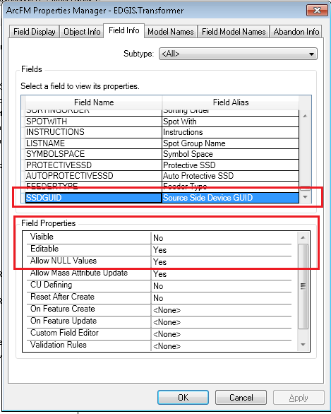

1. Click Apply. Click OK.
2. Repeat step#3 and step#4 for EDGIS.PrimaryMeter and EDGIS.DCRectifier.

## 25686: Modify Device Manufacturer E2 Description to EATON in Device Manufacturer Domain and ED0006 domains.xml

1. Open ArcCatalog with EDGIS user.
2. Right click on database connection and select “Properties…”.
3. Go to “Domains” tab. Select “Device Manager” Domain.

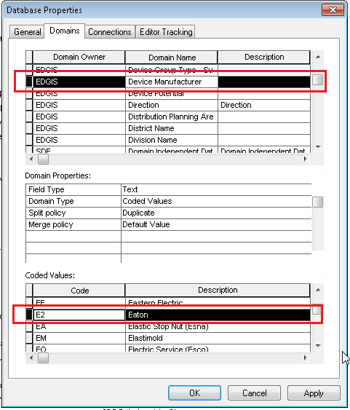

1. Modify the description of E2 to Eaton.
2. Click Apply. Click OK.

## 25830: Assign PGE_CGC12 field model name to CGC12 field of ServicePoint table

1. Open ArcCatalog and connect to the database with EDGIS user.
2. Navigate to ServicePoint table. Right click on it. Select ArcFM Properties Manager.
3. Go to Field Model Names tab. Select CGC12 field. Assign PGE_CGC12 field model name.
4. Click on Apply. Click on OK.

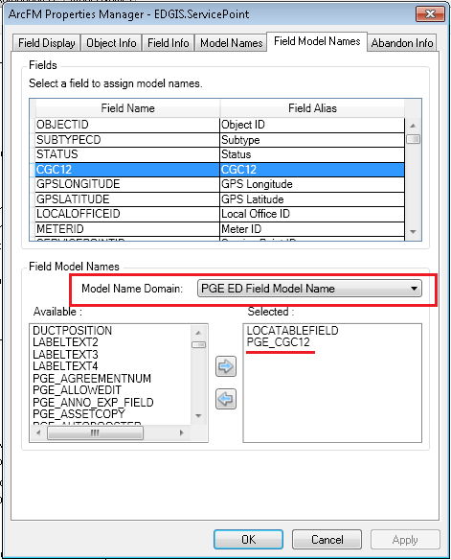

# Update Data Model Version Table

**Database Configuration:**

1. Open SQL Plus.
2. Log in using the same server and user as was used in section 2.1.  
     
   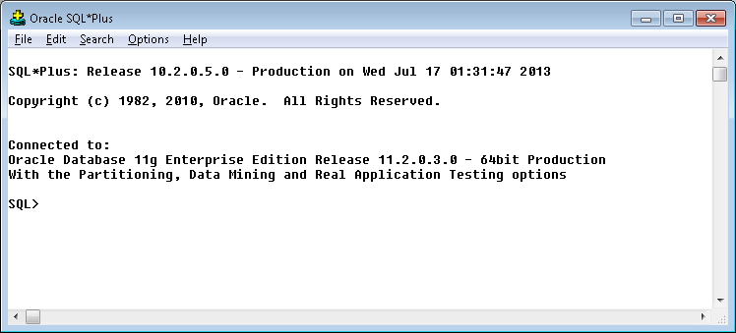
3. Run the SQL below:

update pgedatamodelversion set currentidc='N' where currentidc='Y';

insert into pgedatamodelversion (OBJECTID, CURRENTIDC, DATEAPPLIED, APPLIEDBYPERSONNAME, MODELVERSION) values (**SDE.VERSION_USER_DDL.NEXT_ROW_ID('EDGIS',(select registration_id from sde.table_registry where table_name='PGEDATAMODELVERSION'))**,'Y',sysdate,'***<your_name>***','**9.8.5** GOLD');

commit;

# Known Issues

<Please List any other issues encountered here while following the document>